**Solar Geoengineering Country Report - Outline**

*Length: Aim for at least 2000 words and don’t exceed 4000 words (you will be marked down). This word count excludes references.*

*Structure your report with the following sections, the word limits are a suggestion except for the abstract which should not exceed 150 words. The bullet points give a suggestion of the material that each section should cover.*

**Abstract** – 150 word (Limit)

* Give a brief summary of your report (tip: write this last. Also look at a few examples from papers such as the GLENS one cited below and check out this [guide](https://cbs.umn.edu/sites/cbs.umn.edu/files/public/downloads/Annotated_Nature_abstract.pdf))

**Introduction and Country Context** – 500 - 1500 words (include a figure or table if it helps)

* Very briefly introduce climate change and solar geoengineering and why they will matter for your country.
* Give a brief overview of the state of your country, focusing on the main demographic, economic, and geographic factors, though also mentioning any particularly important political and historical factors (is it a dictatorship, has there been war recently, etc.).
* Describe briefly how the state of the country shapes its exposure and vulnerability to climate change.

**Methods** – 100 – 300 words

* Give a brief summary of the GLENS experiments (described [here](https://journals.ametsoc.org/doi/full/10.1175/BAMS-D-17-0267.1)) and the analysis you conducted, e.g. the time periods you average over, etc.

**Results** – 1000 – 2000 words, 3-6 figures or tables

* Here is where you will present results showing how the climate is simulated to change under the global warming scenario (Control) and under the Geoengineering scenario (Feedback) over the 21st Century.
* The focus of this section is to explain the analysis conducted in the figures and briefly describe the results, leaving the discussion of their implications to the next section.
* Number all your figures and give them captions (see guidance below).

**Discussion and conclusion** – 500 - 1000 words

* Briefly discuss the implications of your results for your country, referring to the factors described in the introduction and country context.
* Optionally, briefly discuss some of the broader issues posed by solar geoengineering and reflect on what your country’s hopes and concerns could be.

**References**

* I’d like you to give references for the main claims you make throughout this report, and include them alphabetically at the end of your report in this references section (see guidance below).

**Guidance on presenting figures**

As a rough guide, I’m expecting between 3 and 6 figures each with between 1 and 4 panels. That is, you can combine multiple global or regional maps that all have something in common into the same figure. Each panel should include a title and the colorbar or axes should be labeled.

You must include a figure caption with each figure that explains what it shows. You can leave general details out if they are common to most of your figures and are explained clearly in the text, e.g. the longitude latitude box, etc.

Number your figures in order and use these figure numbers when you refer to them in the text.

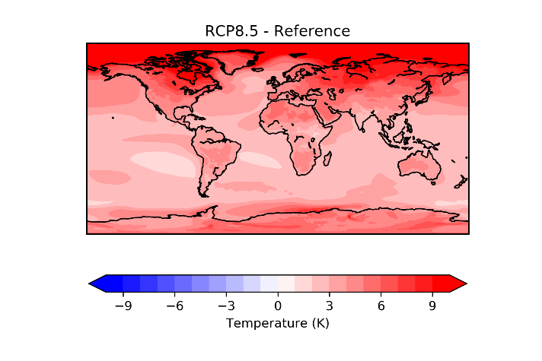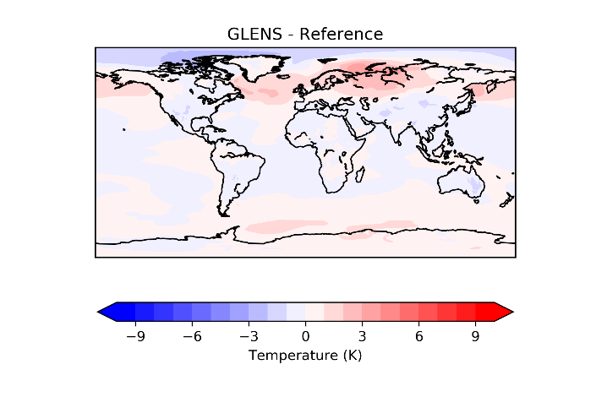 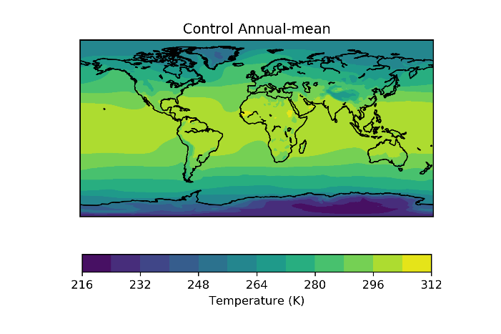

**Figure 0.** Shows the annual-mean surface air temperature response to RCP8.5 (top-left) and GLENS (top-right) relative to the Control period, and shows the control surface air temperature (bottom-right).

***NOTE – I’ll have defined each case: Control, RCP8.5 and GLENS and their respective time periods elsewhere in my report.***

**Guidance on referencing**

Simply put it should be clear where your claims have come from and I should be able to find them using the information given in the references. Here’s some specific guidance for doing this well.

To generate citations for articles, the easiest way is to search in google scholar, read / skim it, then click the quote marks and copy the material there. The format in the text should be [Last Name, Year], [Last Name and Last Name, YEAR], and [Last Name et al. YEAR] for 1, 2 or more authors, e.g. [Rahman et al. 2018] and in the references should appear:

Rahman, A. Atiq, et al. "Developing countries must lead on solar geoengineering research." (2018): *Nature* **556**, 22-24.

Last, First, et al. [for more than 2 authors, or “and first last” for 2] “title” (YEAR): *Journal* **volume number**, pages [or article number]

For websites, I’d suggest citing websites with an author like this in the text [Last Name et al. Year] and ones without an author like this [publisher / website, Year], e.g. [Irvine, 2018] or [CIA, 2019]. For the references section:

CIA, "Yemen." *The World Factbook*. Central Intelligence Agency, 2019. [Web link](https://www.cia.gov/library/publications/the-world-factbook/attachments/summaries/YM-summary.pdf). 20 Feb 2020

Irvine, Peter J., “Less rain but still wetter and greener?”, Harvard’s Solar Geoengineering Research Blog, 2018, [web link](https://geoengineering.environment.harvard.edu/blog/less-rain-still-wetter-and-greener). 20 Feb 2020

For reports, either find them on google scholar or else they usually explain how to cite them somewhere at the front or end of the report so copy that text into the references and cite them in the text as: [Author et al. YEAR] or [Institution, YEAR] if no lead author is evident.